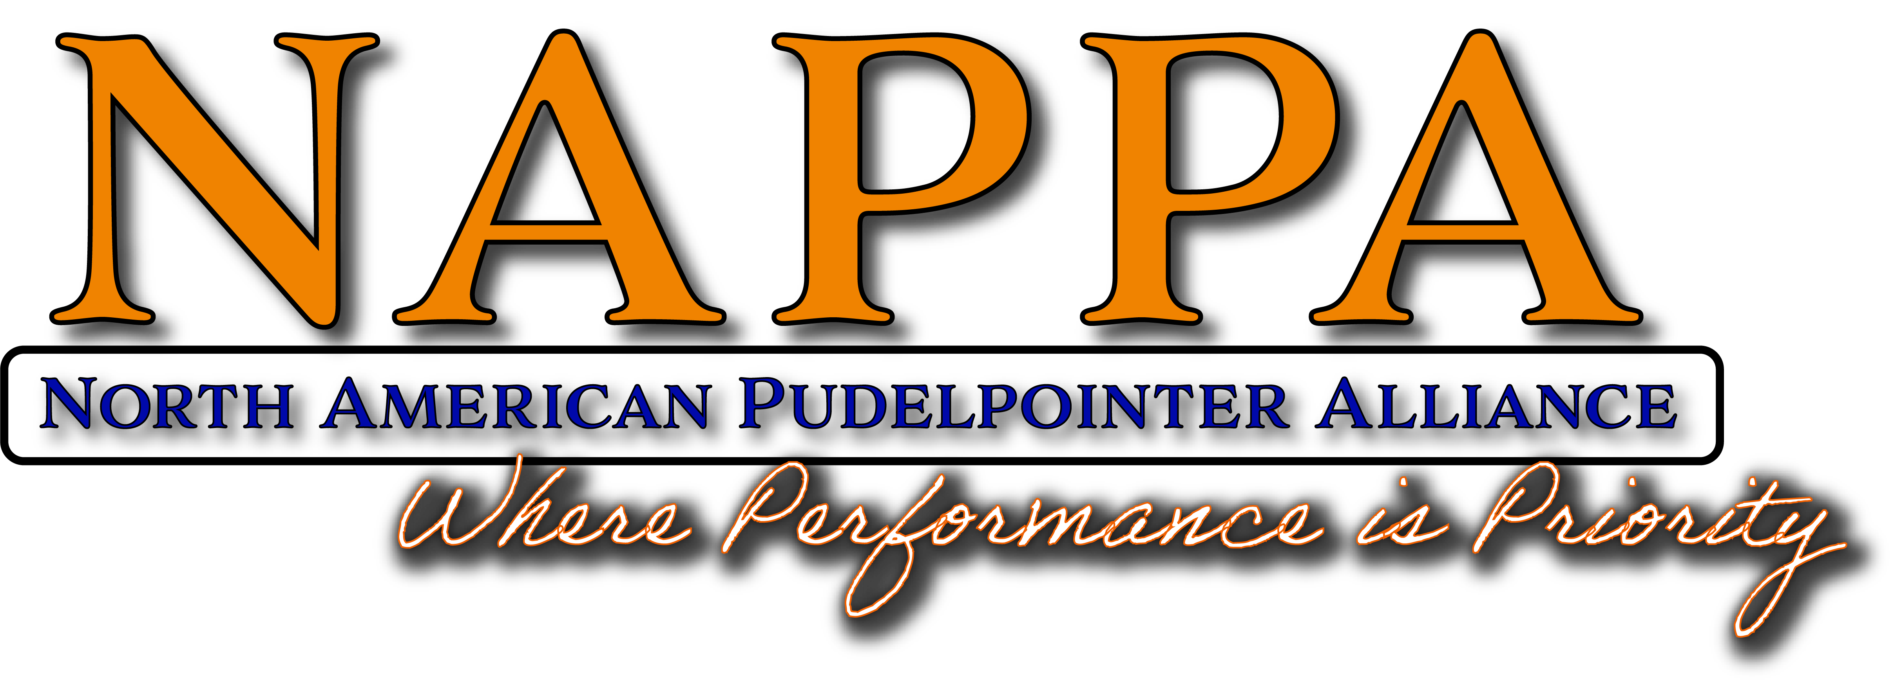
North American Pudelpointer Alliance
Code of Ethical Behavior

PROFESSIONAL RESPONSIBILITY

Core Principle
As NAPPA professionals, we are responsible for adding value to the North American Pudelpointer Alliance and contributing to the ethical success of this organization. We accept professional responsibility for our individual decisions and actions. We are also advocates for the North American Pudelpointer Alliance by engaging in activities that enhance its credibility and value.

Intent
- To build respect, credibility and strategic importance for the Pudelpointer Breeders within the dog organizations, the business communities, and the hunting communities in which we work.
- To inform and educate current and future Pudelpointer breeders, owners, and hunters about principles and practices that help the North American Pudelpointer Alliance in achieving its objectives and goals.
- To positively influence the breeding practices of our members in order to maintain the best of the best Pudelpointers worldwide.
- To encourage professional decision-making and social responsibility.

Guidelines
- Adhere to the highest standards of ethical and professional behavior.
- Measure the effectiveness of our programs in contributing to or achieving organizational goals.
- Work that raises the bar on the values of the profession.
- Strive to achieve the highest levels of service, performance and social responsibility.
- Advocate for the appropriate use and appreciation of Pudelpointers as hunting dogs and family members.
- Advocate openly and within the established forums for debate in order to influence decision-making and results.

PROFESSIONAL DEVELOPMENT

Core Principle
As professionals we must strive to meet the highest standards of competence and commit to strengthen our competencies on a continuous basis.

Intent: To expand our knowledge of breeding and caring for high performing Pudelpointers.

Guidelines
- Pursue formal academic opportunities.
- Purse opportunities for a mentor / mentee relationship with both peers and customers.
- Commit to continuous learning, skills development and application of new knowledge related to both performance and health of the Pudelpointer breed.
- Contribute to the body of knowledge, the evolution of the profession and the growth of individuals through teaching, research and dissemination of knowledge.
- Pursue certification or comparable measures of competencies and knowledge.

ETHICAL COMMUNICATIONS

Core Principle
North American Pudelpointer Alliance professionals are expected to exhibit individual leadership as a role model for maintaining the highest standards of ethical conduct.

Intent
- To set the standard and be an example for others.
- To earn individual respect and increase our credibility with our customer base.

Guidelines
- Be ethical; act professional in every interaction in which you represent NAPPA.
- Treat people with dignity, respect and compassion to foster a trusting working relationship free of harassment, intimidation, and unlawful discrimination.
- Seek expert guidance if ever in doubt about the ethical propriety of a situation.
- Through teaching and mentoring, champion the development of others as ethical leaders in the profession and in organizations in which NAPPA interacts.
- NAPPA members are expected to address all complaints to NAPPA’s seven member board of directors prior to discussions with entire NAPPA membership.
- To represent NAPPA and only NAPPA as the Premier Pudelpointer Breeders group. To stand firmly on not causing confusion to prospective buyers by adding credibility to other Pudelpointer specific advertisements. NAPS has formed a breed specific Breeders advertisement and it is a violation of this rule to be advertising on both NAPPA and NAPS.

FAIRNESS AND JUSTICE

Core Principle
As NAPPA professionals, we are ethically responsible for promoting and fostering fairness and justice for all member kennels and their customers.

Intent To create and sustain an environment that encourages all individuals and the North American Pudelpointer Alliance to reach their fullest potential in a positive and productive manner.

Guidelines
- Respect the uniqueness of individual kennel decisions. Just because it’s not a decision that you would have made, doesn’t mean it’s the wrong decision.
- Develop, administer and advocate policies and procedures that foster fair, consistent and equitable treatment for all.
- Regardless of personal interests, support decisions made by our organizations that are both ethical and legal.

USE OF INFORMATION

Core Principle
NAPPA professionals consider and protect the rights of individuals, especially in the acquisition and dissemination of information while ensuring truthful communications and facilitating informed decision-making.

Intent
To build trust among all organization constituents by maximizing the open exchange of information, while eliminating anxieties about inappropriate and/or inaccurate acquisition and sharing of information

Guidelines
- Acquire and disseminate information through ethical and responsible means.
- Investigate the accuracy and source of information before allowing it to be used in decisions made by NAPPA.
- Safeguard restricted or confidential information.

